实验报告（Lab 4）
姓名：曾泇睷 学号：1820221053
实验：Static and Default Routing
Lab 4-1 STATIC AND DEFAULT ROUTE CONFIGURATION
Requirements
The network topology is shown in Figure 4-1. Four routers are used to interconnect the networks of different departments on the campus. Please configure static or default routes on the four routers to implement communication between departments A, B and loopback 0 (where loopback 0 simulates a host on the network of other departments).
Step 1: Create the topology, cable a network.
Step 2: Assign the IPv4 address and subnet mask for each PC.
Step 3: Start devices.
Step 4: Assign IP addresses to interfaces on the routers.
Step 5: Verify the basic configurations.
Step 6: Configure static routes on the routers.
Step 7: Verify the static route configurations.
Step 8: Configure default routes on the routers.
Step 9: Verify the default route configurations.
Answer the following questions:
Q4-1.1. Paste the screenshot of the created topology.
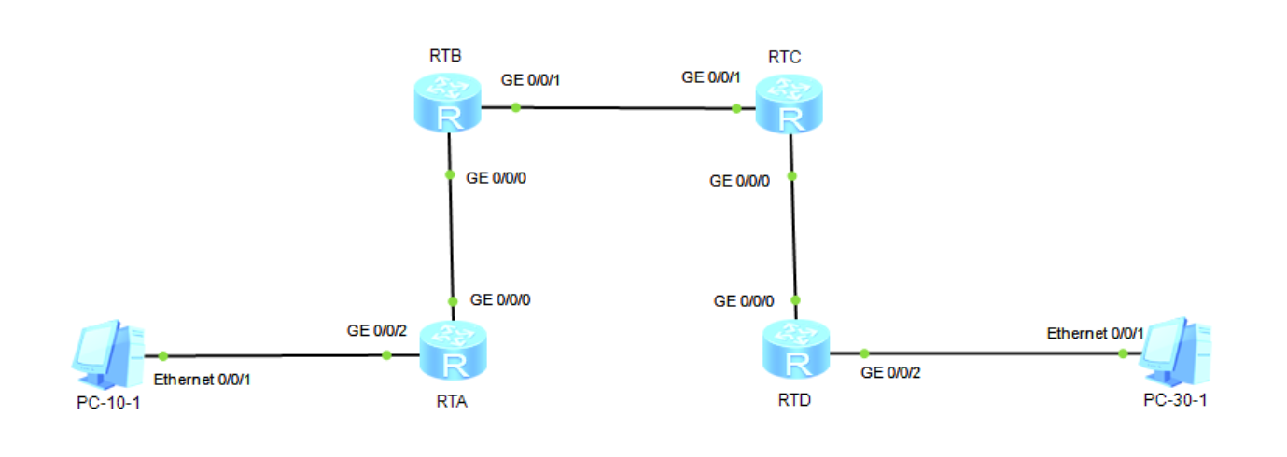

Q4-1.2. Paste the screenshot of the IP routing table on the router RTA.
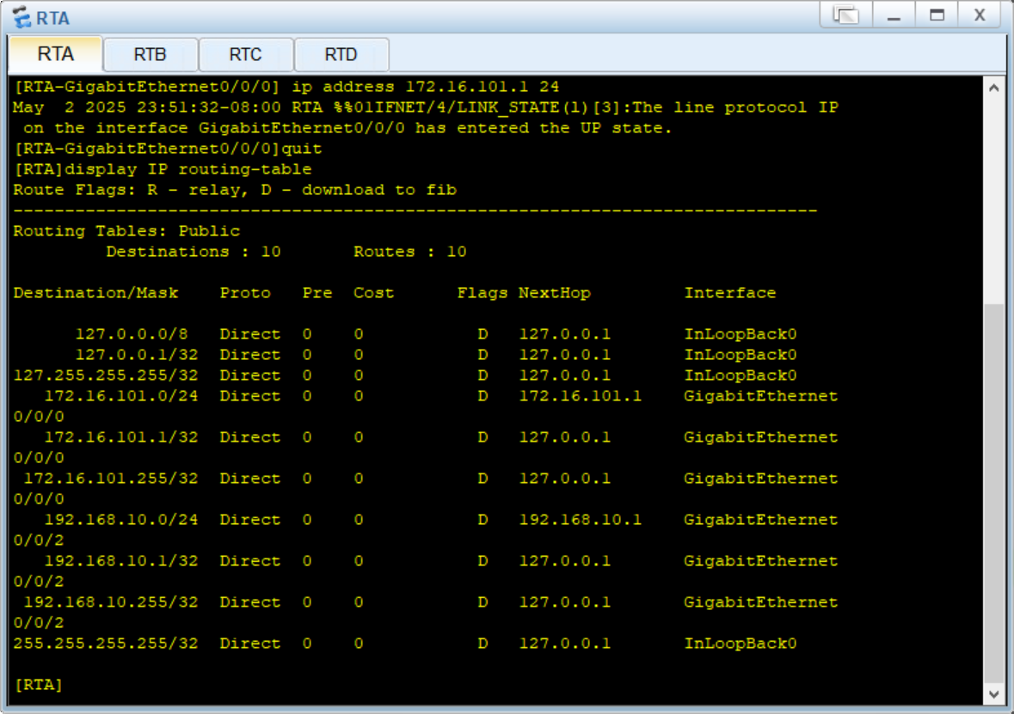
Q4-1.3. Paste the screenshot of the IP routing table on the router RTB.
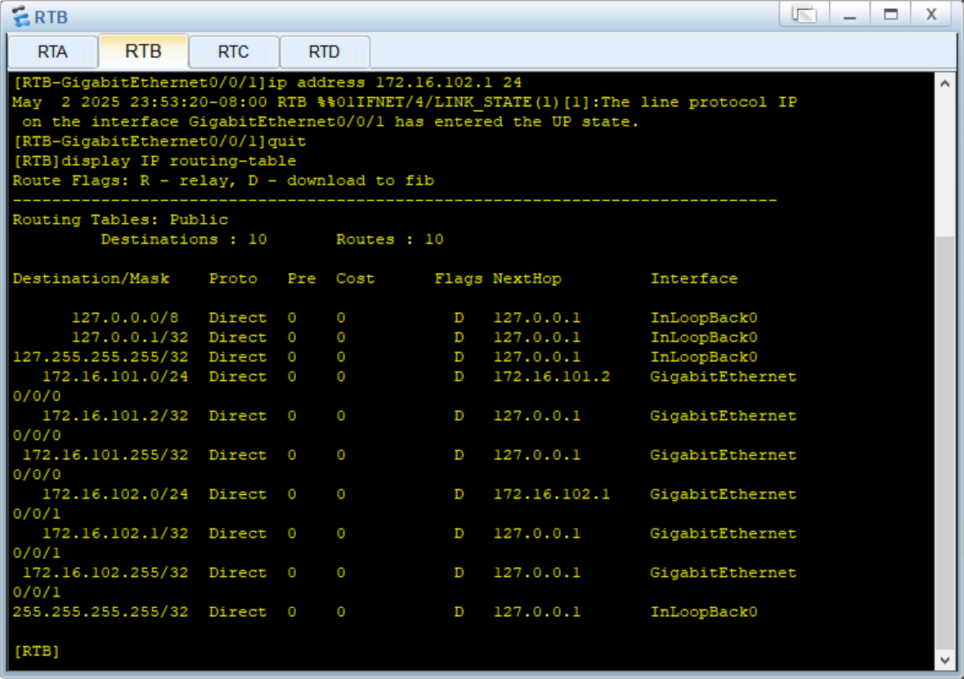

Q4-1.4. Paste the screenshot of the IP routing table on the router RTC.
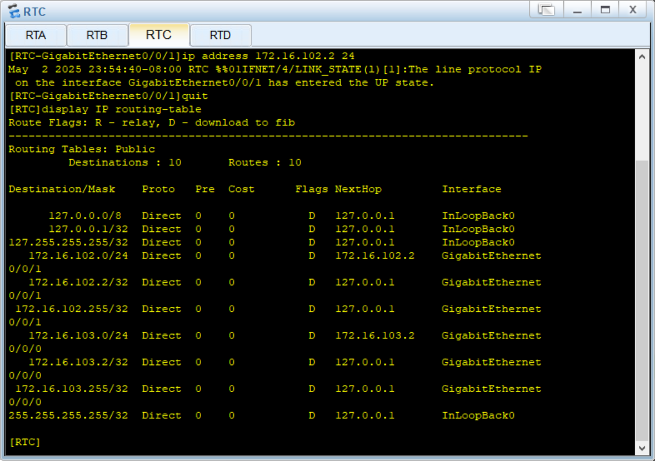
Q4-1.5. Paste the screenshot of the IP routing table on the router RTD.
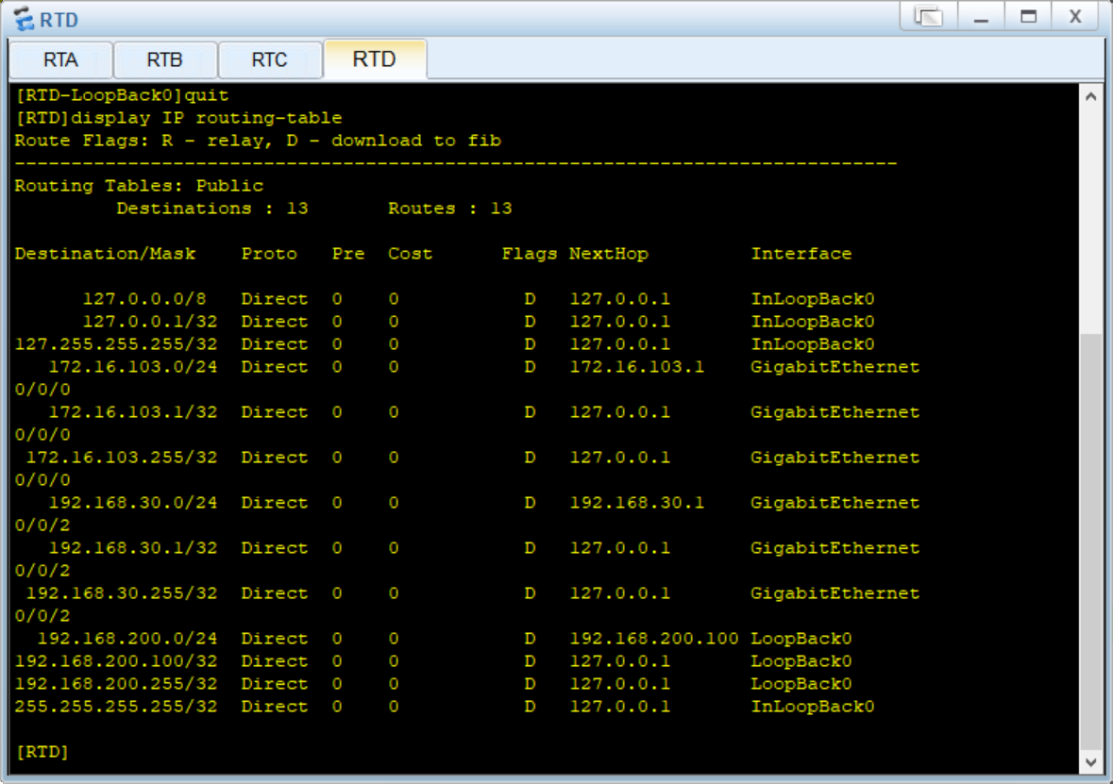

Q4-1.6. Can PC-10-1 and PC-30-1 ping each other? Please paste the screenshot of the ping result.
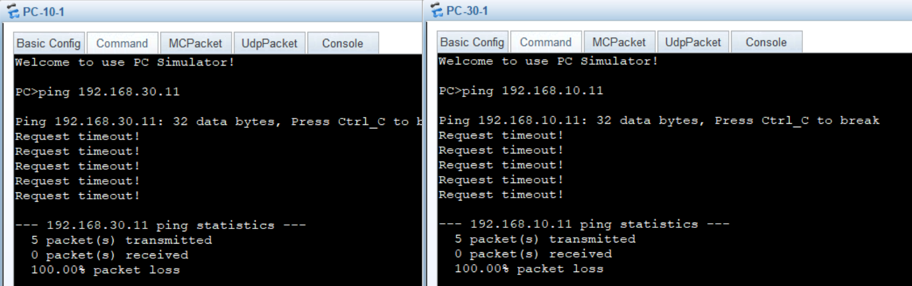
Q4-1.7. Can PC-30-1 and loopback 0 on RTD ping each other? Please paste the screenshot of the ping result.
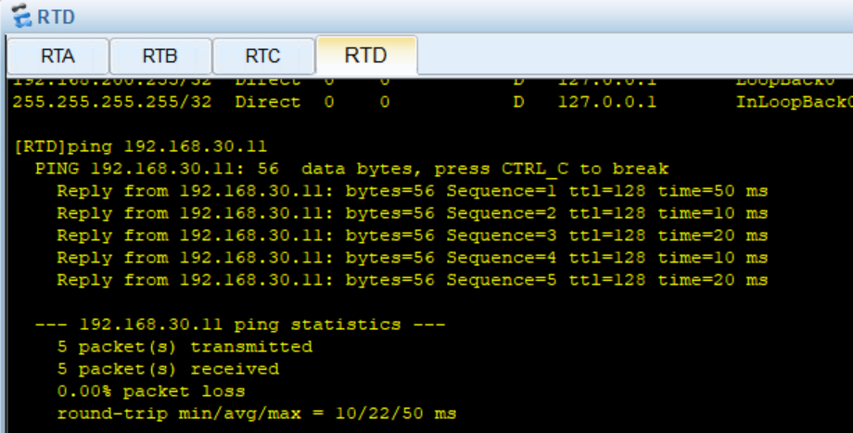
Q4-1.8. Can PC-10-1 and loopback 0 on RTD ping each other? Please paste the screenshot of the ping result.
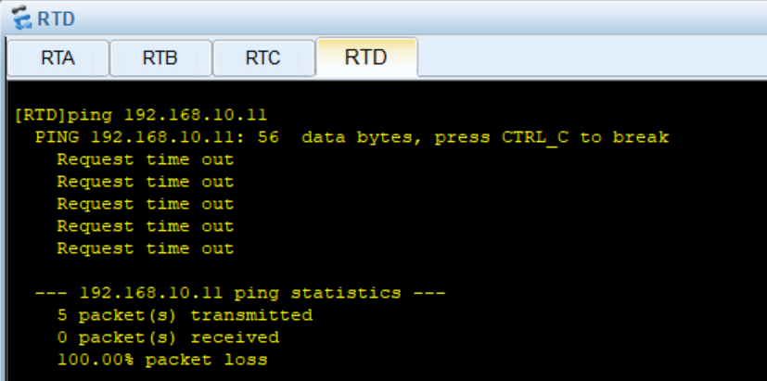

Q4-1.9. Paste the screenshot of the IP routing table on the router RTA.
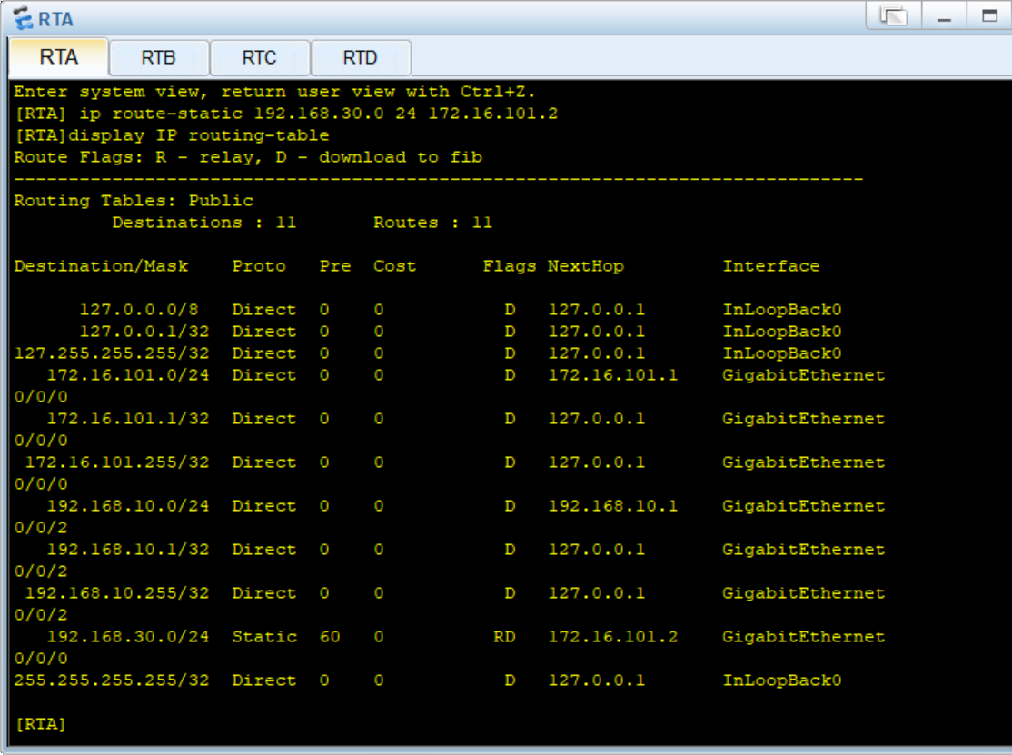
Q4-1.10. Paste the screenshot of the IP routing table on the router RTB.
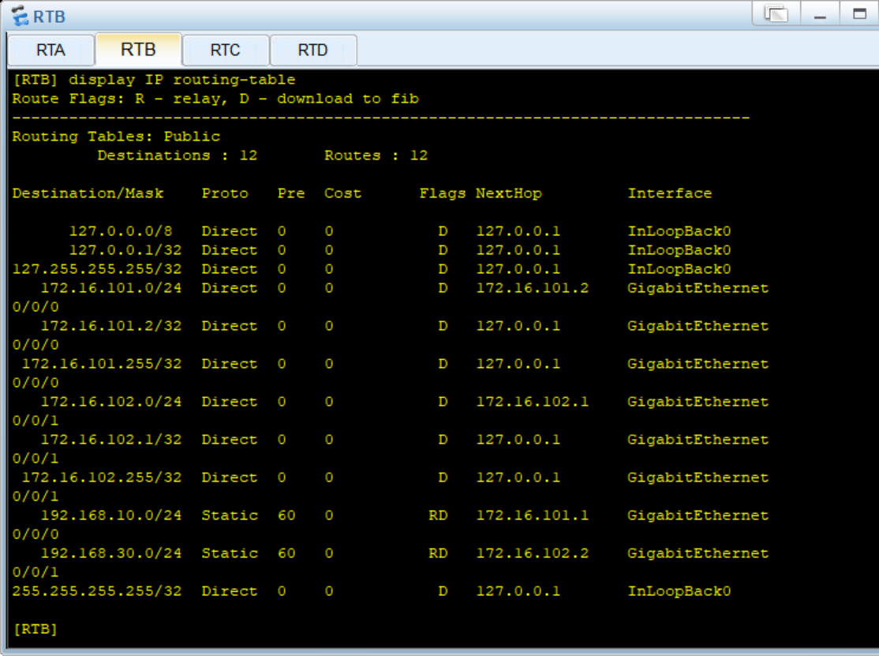
Q4-1.11. Paste the screenshot of the IP routing table on the router RTC.
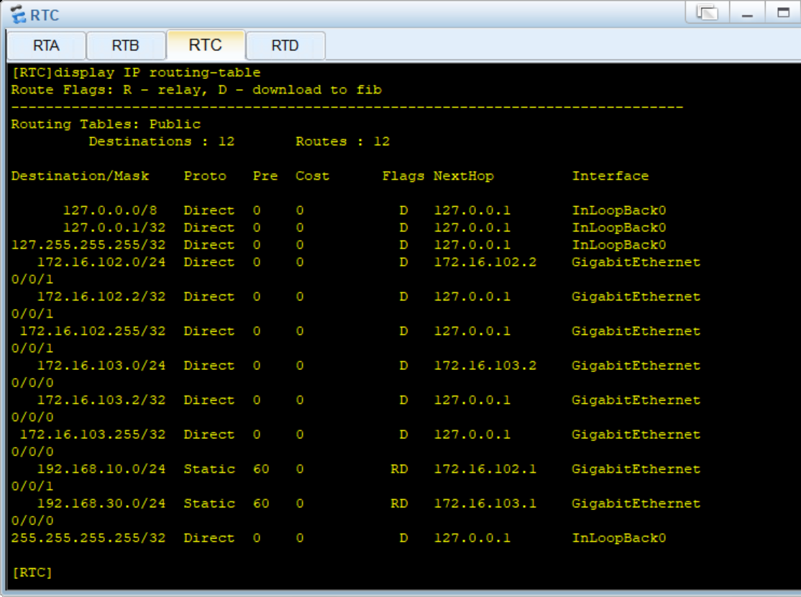
Q4-1.12. Paste the screenshot of the IP routing table on the router RTD.
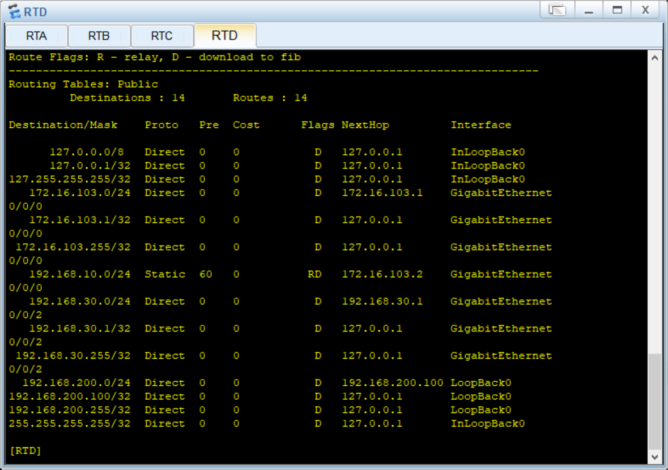

Q4-1.13. Can PC-10-1 and PC-30-1 ping each other? Please paste the screenshot of the ping result.
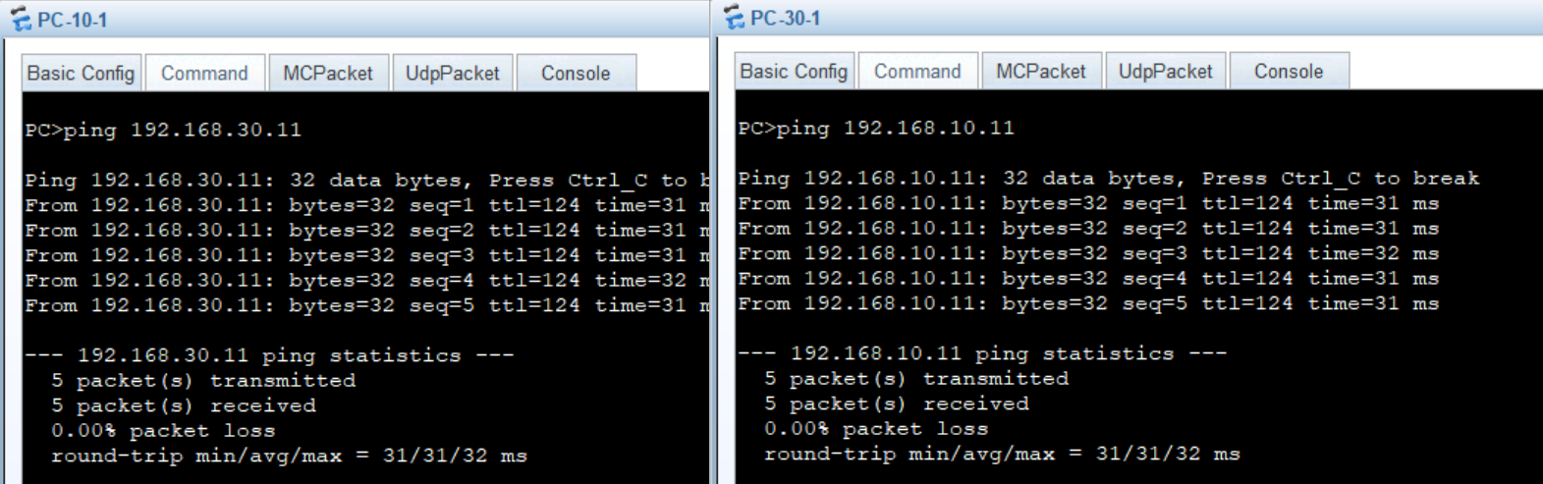
Q4-1.14. Can PC-10-1 and loopback 0 on RTD ping each other? Please paste the screenshot of the ping result. If they cannot ping each other, please explain why.
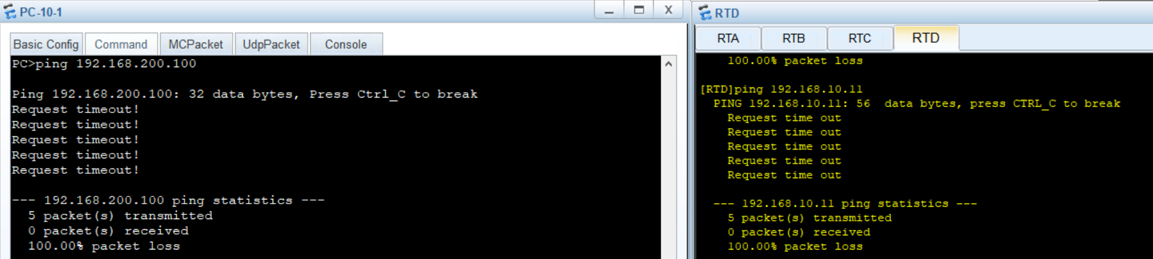
After configuring static routes, PC-10-1 and the loopback 0 on RTD may still not be able to ping each other because the static route configuration might be incomplete or incorrect. Specifically, if RTD does not have a route back to the 192.168.10.0/24 network, the ping packets from loopback 0 will not reach PC-10-1, and vice versa. Additionally, the static route on RTD might have been misconfigured

Q4-1.15. Please paste the screenshot of the result of command “tracert 192.168.30.11” issued from PC-10-1.
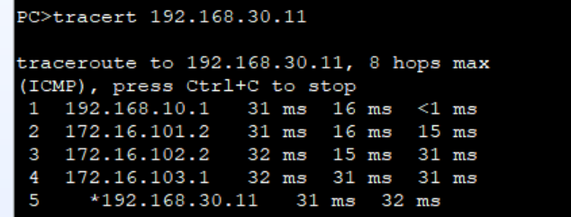

Q4-1.16. Paste the screenshot of the IP routing table on the router RTA.
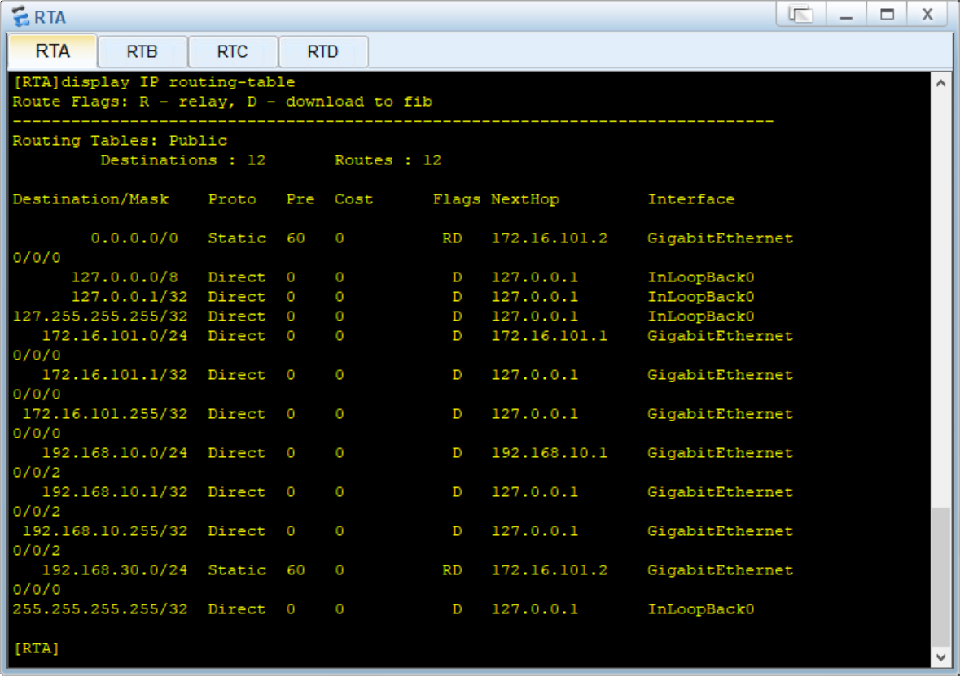
Q4-1.17. Paste the screenshot of the IP routing table on the router RTB.
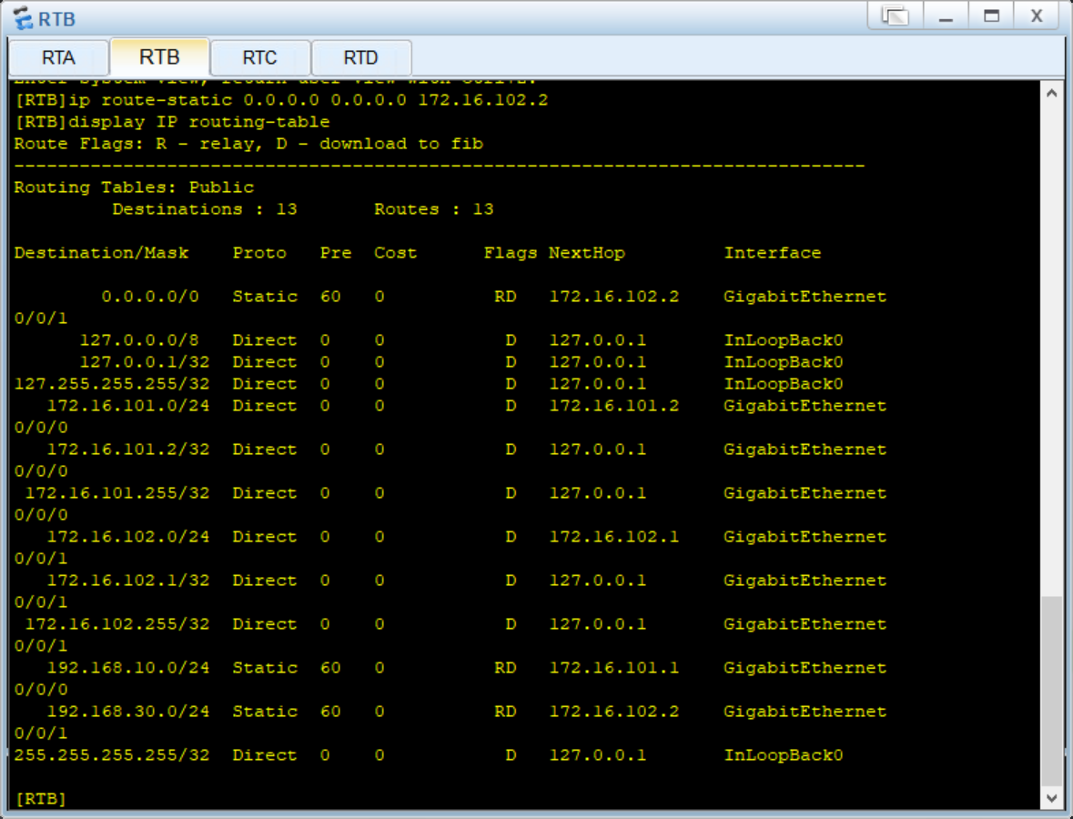
Q4-1.18. Paste the screenshot of the IP routing table on the router RTC.
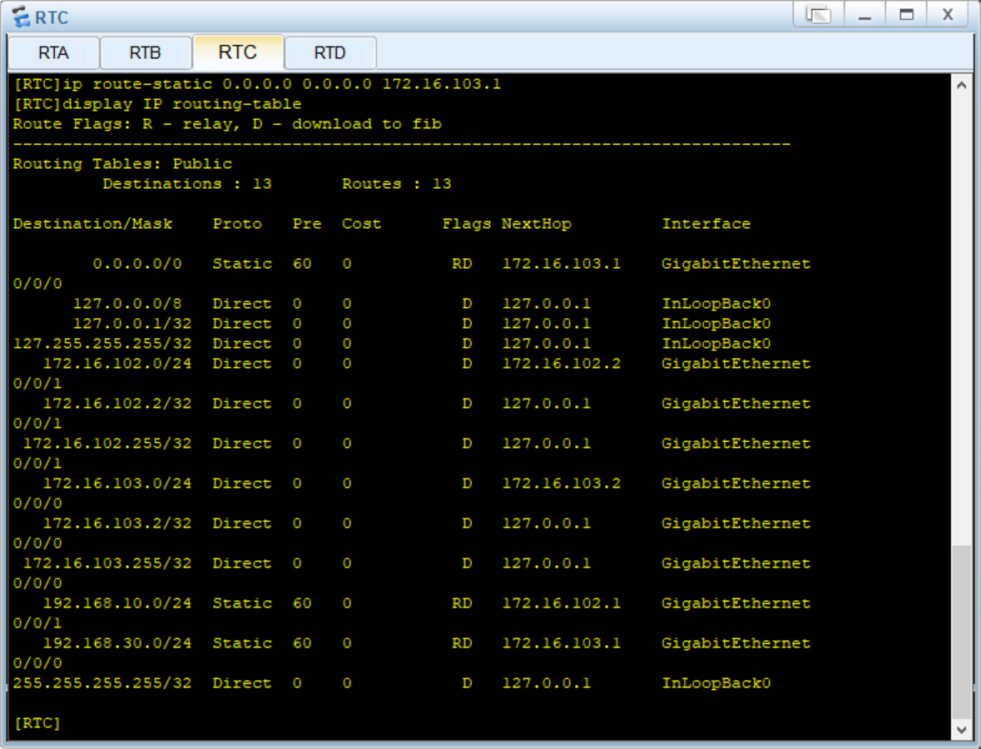
Q4-1.19. Paste the screenshot of the IP routing table on the router RTD.
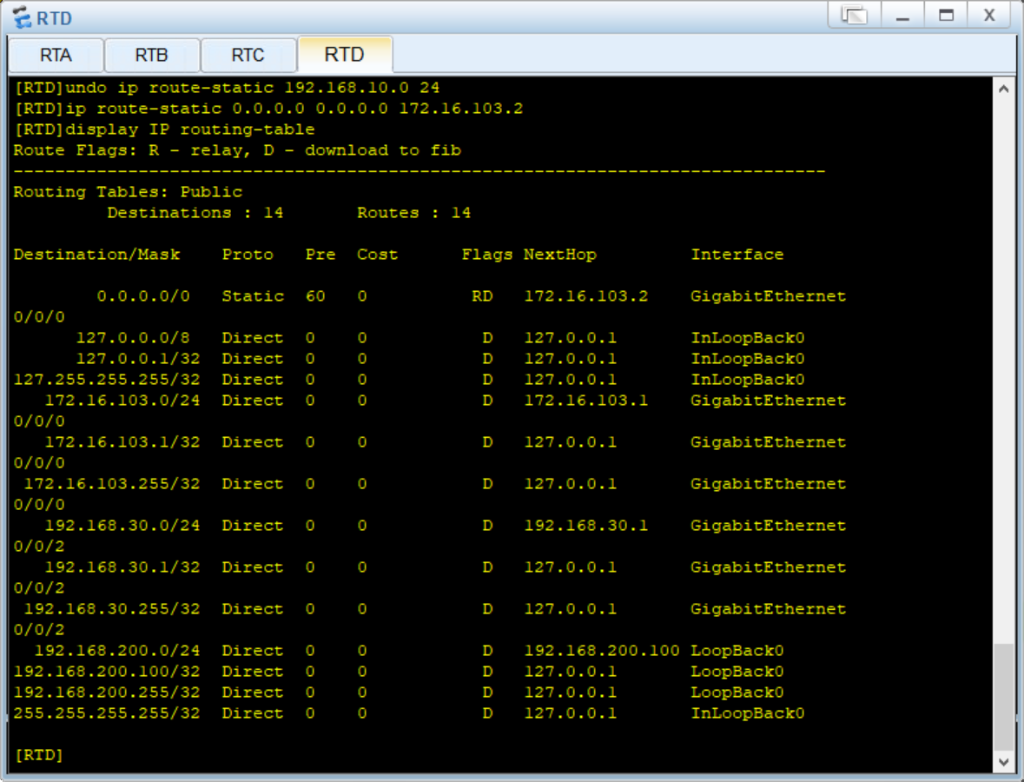
Q4-1.20. Can PC-10-1 and Loopback 0 on RTD ping each other? Please paste the screenshot of the ping result. If they can ping each other, please explain why.
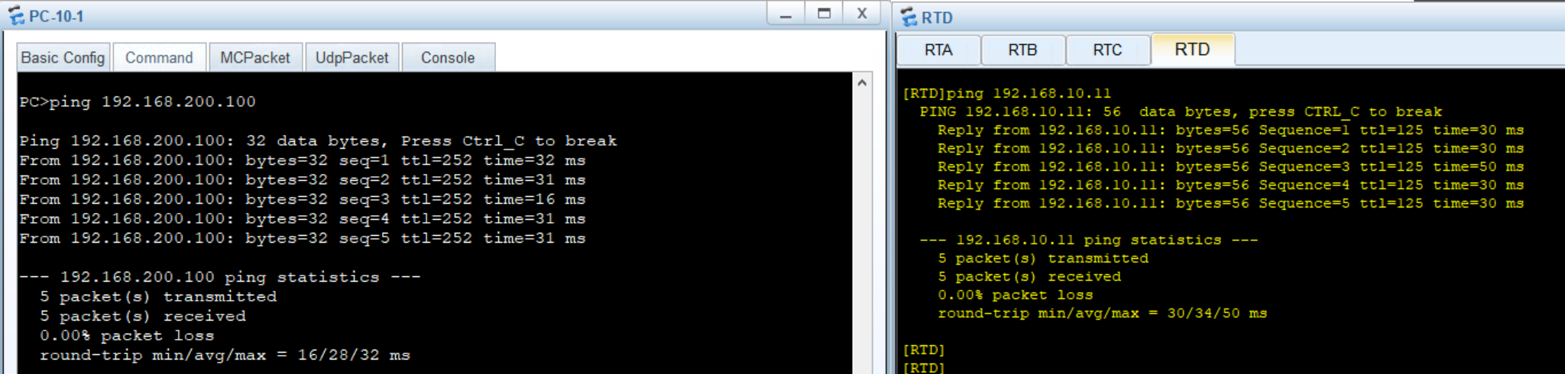
After configuring default routes, PC-10-1 and the loopback 0 on RTD should be able to ping each other. This is because the default routes (0.0.0.0/0) direct all traffic for unknown networks to the next-hop router, creating a path for communication between the two networks.

